**Options for securing cylinders when a wall bracket can’t be used**

This type is more stable than the type shown at the end of this document. Several MIT labs use it.

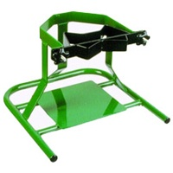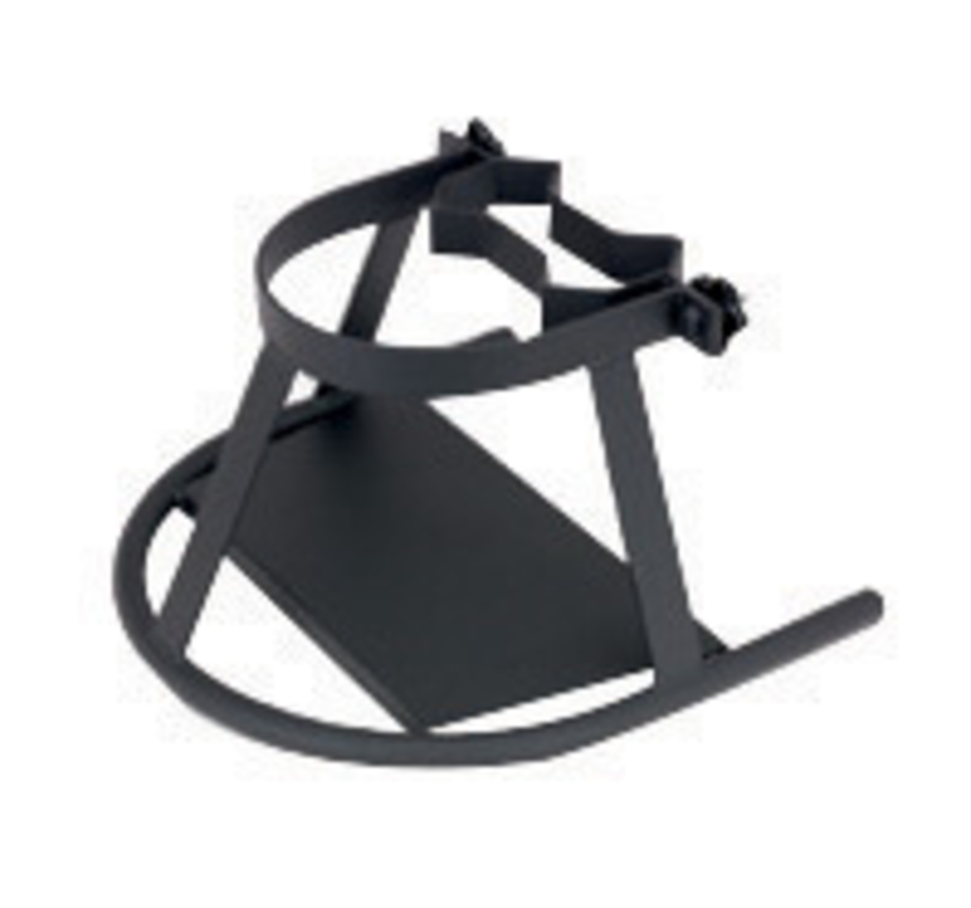

These 2 models have a Bar with 2 sizes of brackets. The bar can be turned over to change sizes depending on the diameter of the cylinder. 2 wing nuts are used to tighten the bar.

The green stand’s Airgas Part Number for 9" - 9½“ diameter cylinders ANT610F-E.

Dimensions: 17” wide x 18” deep x 12” high

The black stand’s Airgas Part Number for 7" - 9½" diameter cylinders RAD64003562

Dimensions: 18” wide x 18” deep x 11” high

This type is not as good because it has a strap, which can fray because it has to be pulled really tight.

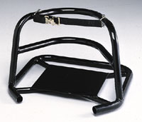

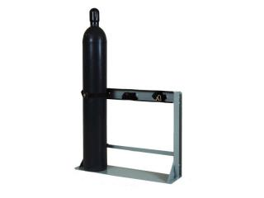

**USA Safety and Fisher sells this type (**Several MIT labs use this type. It’s only designed for full size cylinders.)

**This is one size:**

**USA Safety Model# GR375FS**

**Cylinder capacity:** 1-3   
**Cylinder diameters:** Up to 12"   
**Cylinder stand dimensions (WxDxH):** 40" x 12" x 30"

• Constructed from 11 gauge and heavier plate steel

• Mounts to the floor or the wall

**Fisher Model#** 17989111

**Cylinder capacity:** 4

**Cylinder diameters:** 4 to 12 in. dia.

**Cylinder stand dimensions (WxDxH):** 24x 30

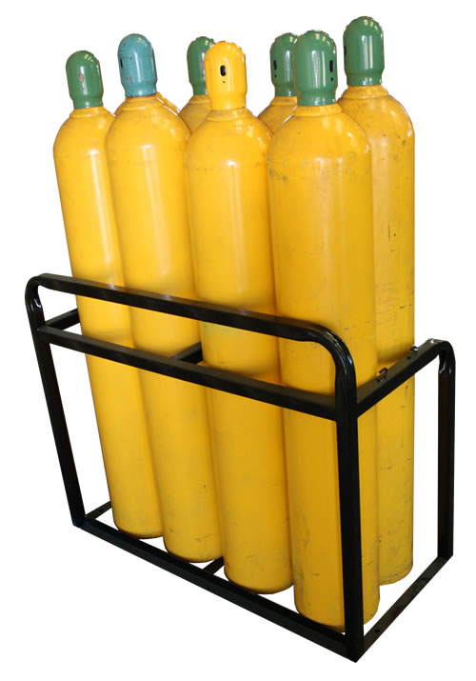

Saftcart storage racks

<http://www.saftcart.com/Site/Cylinder%20Stands.dwt>

For small cylinders

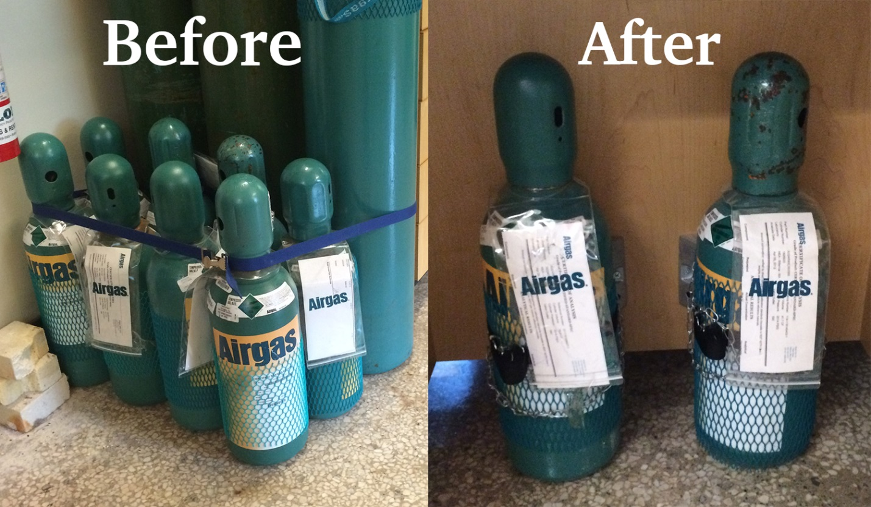

**Do Not purchase these types because they are NOT stable enough for full size cylinders, based on input from MIT EHS staff and EHS Coordinators. These are the last option for very small cylinders (height and diameter).**

